SD3 Report

Patterns And Threads

**Factory**

The factory pattern was used to generate the different ship types. This was done by taking in a random string and depending on what the string contained a type of ship was generated.

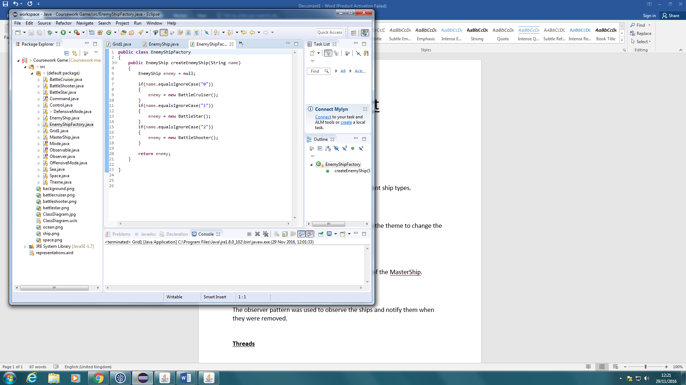

**Command**

The command pattern was used to send an order to the theme to change the GUIs background. This was done by creating a command instance of either the space theme or the sea theme depending on the current state of theme. This then sent as a command to the space or sea theme to execute which then sent a signal to theme changing the background to the one not active.

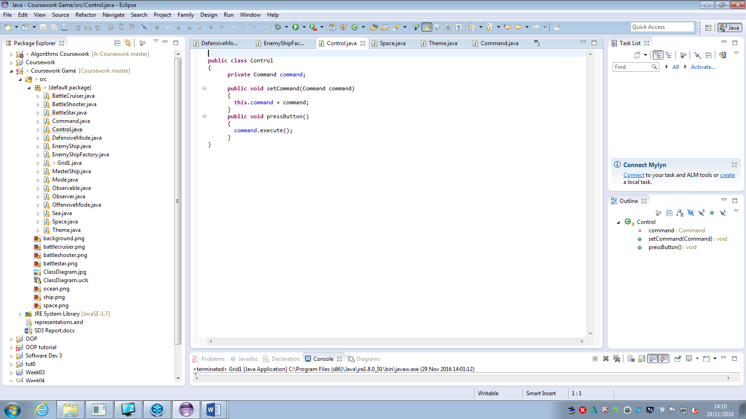

**Strategy**

The strategy pattern was used to change the mode of the MasterShip. When the mode button was pushed the program would check the current mode and set the ship mode behaviour as a new instance of the opposite mode. The new mode would then be displayed on the GUI.

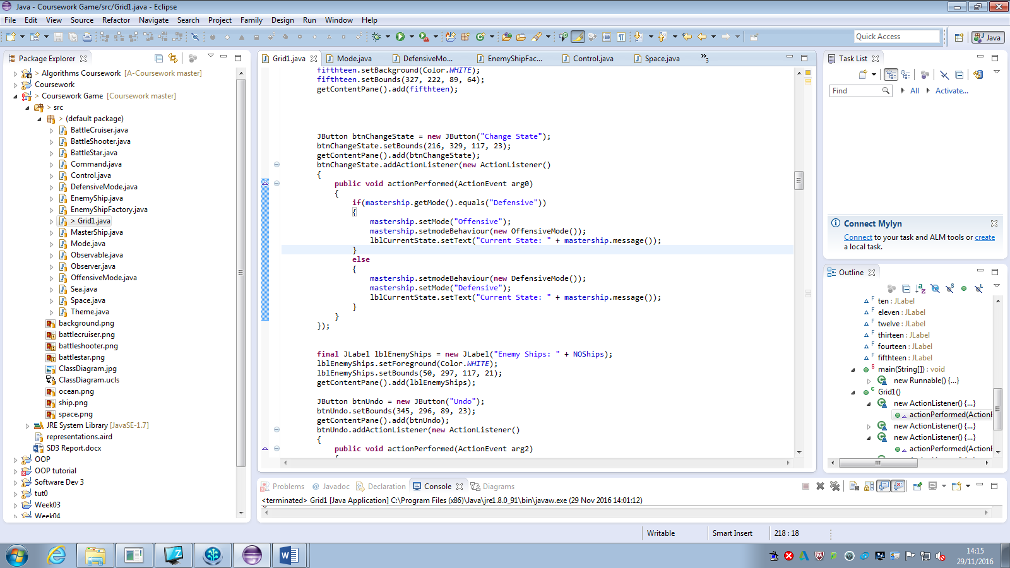

**Observer**

The observer pattern was used to observe the ships on the grid and notify them when they were removed. This was done by adding the ships created into an array and when the ship was destroyed it would be sent a notice and then removed from the array.

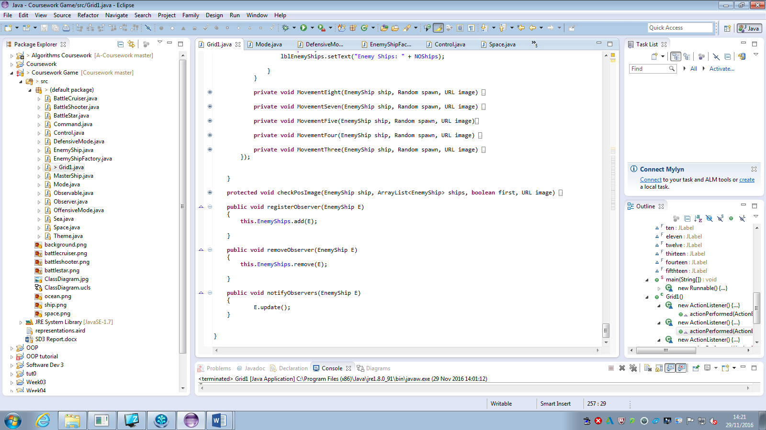

**Threads**

Threads were used to delay the program every time the move and undo button was pressed. This was done by telling the thread to sleep for a certain amount of time.

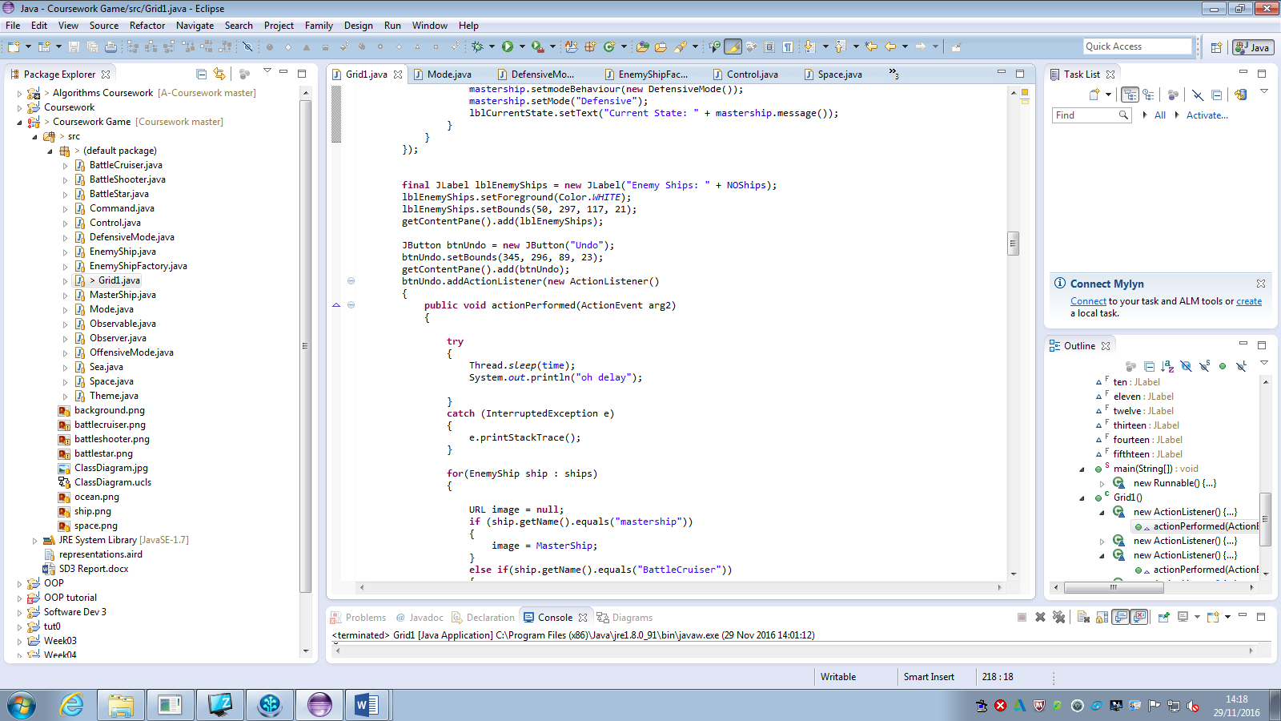

GUI

The GUI consisted of 16 labels that made up the grid, a button to randomly move the ships, a button to change the MasterShips current mode, a button to change the background of the GUI and a button to undo the moves of all ships once.

